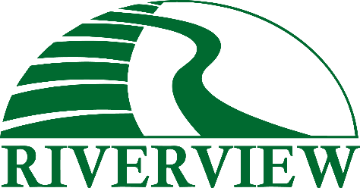
Contact:
Erica Boyum
erica.boyum@riverviewllp.com
218-255-4179

FOR IMMEDIATE RELEASE
Waukon Dairy Hosts Wild Rice Electric Meet n' Greet
Waukon Dairy hosted the Wild Rice Electric Meet n' Greet, welcoming approximately 300 guests to a morning of dairy tours, equipment displays, and community connection. The event brought together five participating organizations — Waukon Dairy, Wild Rice Electric Cooperative, Bongards, Minnkota Power Cooperative, and Skaurud Grain Farms — for an afternoon of hands-on education and family-friendly activities.
Guests enjoyed bus tours through the barn courtesy of Waukon Dairy, with on-site personnel available throughout the day to answer questions. Wild Rice Electric welcomed visitors to its Member Services booth and shared its "Watch the Wires" safety message alongside a bucket truck and equipment display. Skaurud Grain Farms showcased silage and haylage equipment. Bongards hosted an educational booth on the milk production process, complete with cheese samples and product information, and Minnkota Power Cooperative brought a Chevrolet Silverado EV for guests to view, with test drives available throughout the event.
Riverview would like to thank Wild Rice Electric Cooperative, Bongards, Minnkota Power Cooperative, Skaurud Grain Farms, and everyone who came out to make the Meet n' Greet such a success.

About Riverview
Rooted in providing opportunities for the next generation, Riverview’s story began as a crop and beef farm in 1939 and began using the name “Riverview” in the 1970s. Riverview opened its first dairy farm in 1995.
Today, Riverview LLP has grown into a diversified agribusiness that is family and employee owned. Riverview strives to provide a respectful, ethical work environment, ensure animal health and comfort, enhance the productivity of the land, and add value to its communities.

